Dear Ardrey Kell Parents/Guardians,
At the start of the 2023-2024 school year, CMS updated the CMS Grading Plan that included the exemption of a high school final exam for courses that do not have a state-required or EOC assessment if a student met the criteria identified below before the beginning of the exam window:
- Students with a grade of an ‘A’ (90%) or above and no more than 3 absences.
- Students with a grade of a ‘B’ (80%) or above with no more than 1 absence.
- Students would have the option to take the final exam to improve their grade rather than the exemption. If a student chooses to take the exam, CMS grading practices are followed, and the exam counts for 20% of the student’s final grade. Otherwise, the final grade for the course is calculated as follows: 50% quarter 1 + 50% of quarter 2. The final exam grade in PowerSchool will be noted with an ‘EX’ flag for those who have been granted an exemption.
- Students who participate and complete Advanced Placement exams may choose to take the teacher-made final to include in their final grade for the class.
Parents are encouraged to review their child’s current progress in PowerSchool and can see if their child is potentially eligible for the exemption by reviewing the grade in the ‘F1’ column as well as reviewing the number of absences accumulated during the semester (excused and/or unexcused). For students that have a significant undue hardship with attendance due to a medical concern, the principal may exempt the student from participating in a non-EOC/state required final exam pending the review of medical documentation through a Medical Hardship and, if the student has met the academic criteria. Medical Hardship requests must be submitted in writing on the CMS form no later than January 5, 2023. The form can be found on the AK website.
Finally, it is important to note that the final exam exemption is only for non-state required assessments. The QR code below identifies those courses that students are required to take a final exam per state statute.
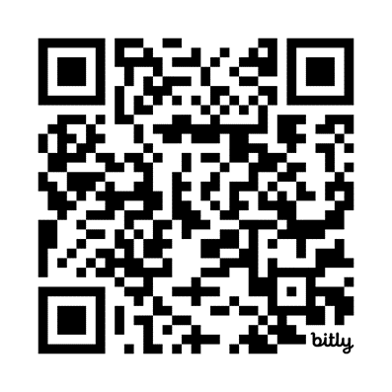
Students who meet the criteria for a final exam exemption will receive communication from their assigned teacher before the beginning of the final exam window. Please contact jamie.brooks@cms.k12.nc.us or your child’s counselor if you have questions regarding the final exam exemption process or if you are considering a request for Medical Hardship.
Sincerely,

Jamie Brooks
Principal

